Circular Economy voluntary commitments

Status as of 29/10/2019

Content:
- Why and what is a voluntary commitment
- Voluntary commitment, page 1 – Statement
- Voluntary commitment, page 2 – About the company
- About the product, page 3 - About the product/s (Example)

A voluntary commitment for Circular Economy (provisional name WAC)

What: Working with its Members and their companies, EURATEX elaborates a circular economy strategy. EURATEX proposes voluntary commitments to value and strengthen the industry role.
“WAC”, a voluntary commitment: EURATEX invites the sector companies to make a step forward and: i) Welcome the EU efforts, ii) share insights of how the companies Act already on circular economy and iii) Commit to further work based on the companies’ interests.
The commitment is made of 3 documents: Page 1 a standard template with a standard core statement. Page 2 a concise overview of the company action on circular economy which can be personalized. Page 3 a fact sheet (one or some) on specific product/ process following strictly the templates of cases published on-line (link)
Why: Voluntary actions supports the consideration of industry interests by policy makers. EURATEX deems crucial to stress the key role of the European industry before the EU institutions by the start of the new EU Commission (expected 2nd December 2019).
What is the commitment about: it is a general commitment on keep working for circular economy and share insights; is a strong signal for policy makers and business partners. No legal provisions.
Why this very commitment: This voluntary action stresses what companies already do.
Current status and planning (as of Tuesday 29th October 2019):
- 28 companies have already confirmed interest to sign voluntary commitment;
- At least 50 companies will be invited to join across the value chain (Fiber makers, Spinners, Fabric makers, Finishers, Final product makers, including vertically integrated companies);
- EURATEX to promote the commitments within its strategy proposal now under discussion within the Membership and due by first week of December 2019;
- EURATEX to keep working with Members and the signing companies to further elaborate proposals for the policy makers for the EU Action plan for circular economy;
- EURATEX to keep collaborating for common goals with partners across the garment value chain (building on the partners and results of the Joint Industry Manifesto) with other partners in the wider textiles value chain, with NGOs and other stakeholders as appropriate.

Background: Promoting the interests of the European industry, EURATEX works with its Members since 2017, on Circular Economy, also promoting the companies’ role and actions.
In May 2019 EURATEX subscribes with world leading fashion organisations a Joint Industry Manifesto urging the EU Institutions to work with the business and jointly develop vision and plan. In September 2019, the new Commission designated President, mandates to deliver a new Circular Economy Action Plan for sustainable resource use in resource-intensive and high-impact sectors, such as textiles.
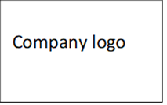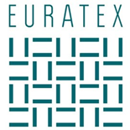

A new Circular Economy Action Plan for sustainable resource use

I wish to WELCOME the effort of the European Commission President Ursula Von Der Leyen to create a green deal and new Circular Economy Action Plan for sustainable resource use

In my capacity of manufacturer in the textiles value chain, my company does already ACT and explores solutions for sustainable resource use as by insights shared hereafter.

I therefore wish to COMMITT to keep working in the pursue of sustainable resource use and offer to contribute with our lessons learned to build up a new Circular Economy Action Plan.

City
Signature
COMPANY LOGO
[Company name] Fact box:
- Headquarters:
- Revenue:
- Employees:
- Investment in R&D / anno:
- Nameplate capacity:
- Website:

Who are we:
Approximately 150 – 200 words. Approximately 150 – 200 words. Approximately 150 – 200 words.
Approximately 150 – 200 words. Approximately 150 – 200 words. Approximately 150 – 200 words.
Approximately 150 – 200 words. Approximately 150 – 200 words. Approximately 150 – 200 words.
Approximately 150 – 200 words. Approximately 150 – 200 words. Approximately 150 – 200 words
Approximately 150 – 200 words. Approximately 150 – 200 words. Approximately 150 – 200 words.
Approximately 150 – 200 words. Approximately 150 – 200 words. Approximately 150 – 200 words.
Approximately 150 – 200 words. Approximately 150 – 200 words. Approximately 150 – 200 words.
Approximately 150 – 200 words. Approximately 150 – 200 words. Approximately 150 – 200 words

How do we drive circularity in the textile industry:

Approximately 150 – 200 words ideally also bullet points. Approximately 150 – 200 words ideally also bullet points. Approximately 150 – 200 words ideally also bullet points. Approximately 150 – 200 words ideally also bullet points. Approximately 150 – 200 words ideally also bullet points. Approximately 150 – 200 words ideally also bullet points. Approximately 150 – 200 words ideally also bullet points. Approximately 150 – 200 words ideally also bullet points. Approximately 150 – 200 words ideally also bullet points. Approximately 150 – 200 words ideally also bullet points. Approximately 150 – 200 words ideally also bullet points. Approximately 150 – 200 words ideally also bullet points. Approximately 150 – 200 words ideally also bullet points. Approximately 150 – 200 words ideally also bullet points. Approximately 150 – 200 words ideally also bullet points. Approximately 150 – 200 words ideally also bullet points.

What have we committed so far:
- Capital investments: approximately Euro x million, planned >Euro xx million (from date – till today)
- R&D investments: approximately Euro xx million
- Dedicated resources: approximately x FTE’s (footnote FTE: Full Time Equivalent)
About the product

Title of the initiative/project

What is the circular economy example about?
(max. 200 words). Try to limit technical complexity to a minimum.

Added value
(What is the added value in terms of waste reduction, reuse of materials, emissions reductions, etc.?)
(max. 150 words). Use bullets if possible.

Challenges

(What are the main challenges (preferably regulatory and/or financial)?)
(max. 150 words). Use bullets if possible.

Company name:
Website:
SMEs Yes or NO

Contact person: only: name, email & phone

Pictures
(Please add 3 pictures or up to maximum 7 pictures in vertical format, maximum size of 2MB each, please describe each pic hereafter)
Pic. 1:

Pic. 2:

Pic. 3:
Please add more if necessary

Thanks to a collaboration between the industry associations Euratex and Business Europe, the final version of this success case will be uploaded on www.circulary.eu.
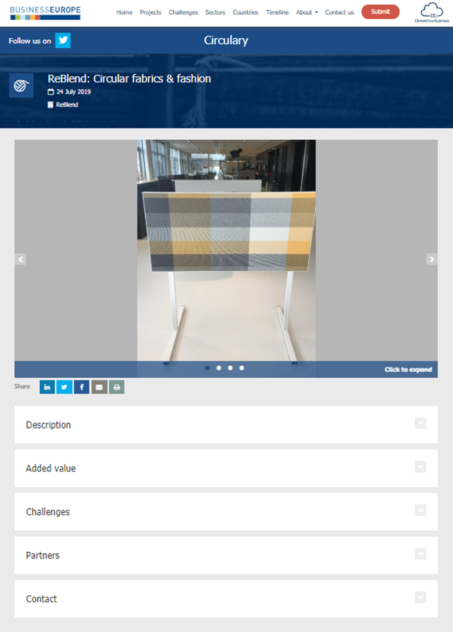

Small and medium-sized enterprises (SMEs)

